OUR GOALS
The field of professional activity of a Marketing specialist : "Marketing" is the business process of the flow of goods and services from the manufacturer to the consumer.
Purpose of training
The training of specialists is the connection between the manufacturer and the consumer, to help them find each other and thereby make a profit.
A marketing specialist is someone who:
-conducts research, is able to know what consumers want;
- - plans advertising campaigns;
- analyzes competitors;
- determines how much the product should cost;
- offers where it is more convenient to promote products;
- participates in the development of new products
- Students who have completed training in the "Marketing" program can work;
- Managers and specialists of marketing services of companies
- Digital marketers
- Brand managers
- By market analysts
- Key account managers
- Sales department managers
- Smm marketer

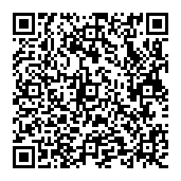
EDUCATIONAL PROCESS

Graduates of the Marketing program are able to solve marketing problems related to the creation and introduction of new products to the market, including innovative ones, the development of a product development strategy on the market in the context of globalization, possess the methodology and practice of marketing research, are able to independently organize the implementation of research projects, prepare analytical materials for management decisions in the field of strategic and operational marketing.

FORMS AND TERMS OF TRAINING

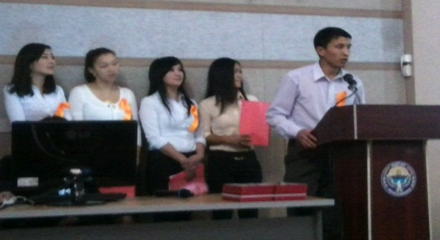
Qualification: marketing specialist
Forms of study: full-time/part-time
Duration of training: 4 years
Graduates receive a diploma of I. Razzakov KSTU.

OUR CAPABILITIES
The department offers students higher educational standards – a unique educational and methodological base with the necessary technical, including multimedia equipment, constantly updated library and reference fund, including electronic resources.
Classes are held in the form of lectures, seminars, practical classes, master classes, round–table discussions, participation in student conferences, trainings and business games using the latest teaching methods.
We have all the necessary intellectual and material resources.
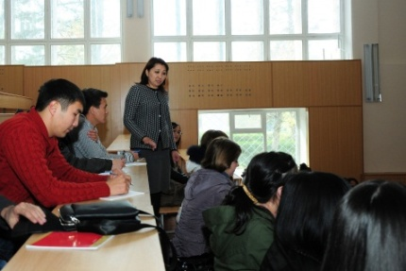
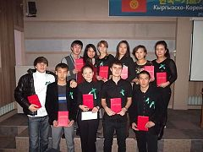

ADMISSION RULES

1. Submit to the admissions committee:
• document on secondary education (certificate);
• ORT certificate (additional mathematics)
• six 3x4 photos;
• passport or other identity documents (military service certificate or military ID card);
• other documents positively characterizing the applicant (diplomas of the Olympiads, certificates of honor, medals, etc.).
2. Fill out an application at the admissions committee.
3. Fill out the contract and pay at least 50% of the annual tuition fee.

Our address:
66 Mira Ave., Bishkek
KSTU, Department "Economic security and marketing"
room 2/314
Our phone numbers:
0 312 54-19-21 (admissions office)
0 312 56-14-20 (EBM Department)
For inquiries 0550317373, 0700323835, 0702647085

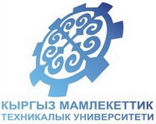
Kyrgyz State University
Technical University
named after I. Razzakov 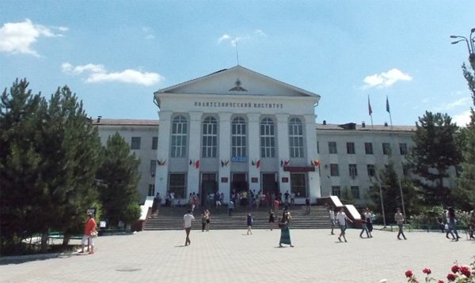

Department
"Economic security and Marketing"
Education is your capital!

Bishkek

