**Publication activities of teaching staff of KSTU named after I. Razzakov**

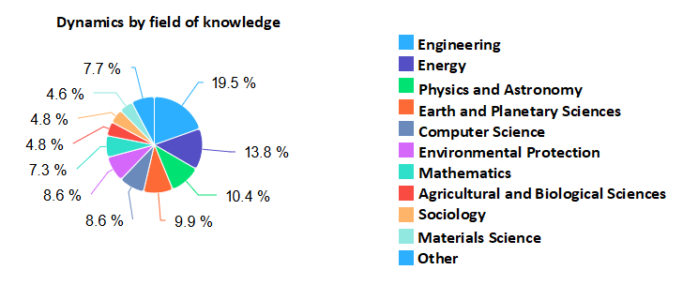

The publication activity of the KSTU faculty over the past 6 years is as follows: 25 articles were published in 2019, 41 in 2020, 52 in 2021, 41 in 2022, 81 in 2023, and 101 articles were published in 2024.

In the Web of Sciences database, the publication activity of the KSTU faculty over 6 years is as follows: 7 articles were published in 2019, 8 in 2020, 9 in 2021, 9 in 2022, 9 in 2023, and 3 articles were published in 2024.

Table 1 shows the list of authors with the largest number of scientific articles published in the Scopus database among the KSTU faculty.

Table 1. Number of published scientific articles of authors from KSTU

|  |  |  |
| --- | --- | --- |
| # | **Full name of the author** | **Number of published scientific articles in the Scopus database** |
| 1 | Bochkarev I.V. | 37 |
| 2 | Chimyrov A. | 17 |
| 3 | Usubamatov R | 15 |
| 4 | Maripov A | 10 |
| 5 | Smanalieva Zh | 8 |
| 6 | Boronbaev E | 7 |
| 7 | Oruzbaeva G | 6 |
| 8 | Orozonova A | 6 |
| 9 | Muratalieva V | 6 |
| 10 | Matkerimov T | 6 |
| 11 | Mamatov Z | 6 |
| 12 | Kadyrov I | 6 |
| 13 | Asanov A | 6 |

In the period 2019-2024, KSTU published articles by 341 authors, of which 439 scientific publications were written with the participation of universities in other countries. The scientific articles presented in the Scopus database cover the following fields of knowledge: engineering - 155 (19.2%), energy - 115 (14.3%), physics and astronomy - 82 (10.0%), earth and planetary sciences - 81 (10.0%), computer science - 67 (8.3%), mathematics - 60 (7.4%), materials science - 37 (4.6%), agricultural sciences and botany - 39 (4.8%).

By document types, scientific articles for the period under review were published in the following categories: Scientific articles - 209, conference proceedings - 204 articles, book series - 17, review articles - 5 and books - 2 articles.