OUR GOALS

The field of professional activity of an Economic Security specialist:
- participation in the development of concepts, strategies and National programs to ensure the economic security of the country and regions;
- in public authorities, such as the Government of the Kyrgyz Republic, the State Tax Service, the State Treasury, the Ministry of Finance of the Kyrgyz Republic, the Ministry of Economy of the Kyrgyz Republic, the National Statistical Committee of the Kyrgyz Republic, etc.;
- in the state authorities of the regional level of management and local self-government bodies performing control and supervisory functions;
- in information and analytical, planning and economic, control and audit departments of state and commercial companies, non-profit organizations, banks and financial and credit companies involved in ensuring the economic security of organizations and identifying threats to economic security.
EDUCATIONAL PROCESS
We train highly qualified specialists capable of performing tasks to ensure the security of individuals, society and the state in the economic sphere: to identify external and internal threats to the economic security of the state, its regions and industries; to apply tools and mechanisms to neutralize and prevent possible threats, to protect the economic interests of public authorities,
the budget system, public and private corporations, banks, investment companies operating both within Kyrgyzstan and abroad.

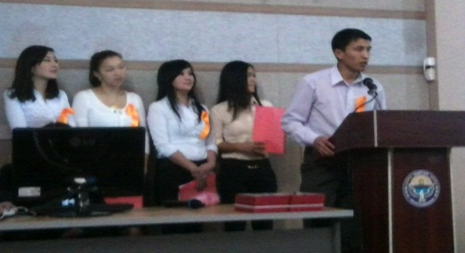
FORMS AND TERMS OF TRAINING
Specialty
Qualification: engineer-economist
Forms of study: full-time
Duration of training: 5 years
Graduates will receive a diploma of I. Razzakov KSTU and F. Ustinov Baltic State Technical University (BSTU "Voenmeh", RF).

OUR CAPABILITIES
The department offers students higher educational standards – a unique educational and methodological base with the necessary technical, including multimedia equipment, constantly updated library and reference fund, including electronic resources.
Classes are held in the form of lectures, seminars, practical classes, master classes, round–table discussions, participation in student conferences, trainings and business games using the latest teaching methods.
We have all the necessary intellectual and material resources..
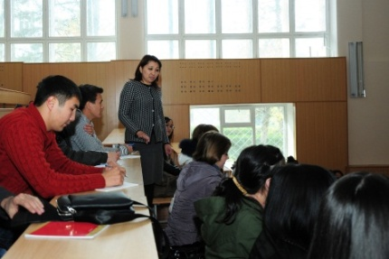
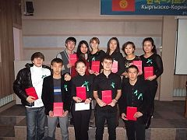

ADMISSION RULES

1. Submit to the admissions committee:
• document on secondary education (certificate);
• ORT certificate (additional mathematics)
• six 3x4 photos;
• passport or other identity documents (military service certificate or military ID card);
• other documents positively characterizing the applicant (diplomas of the Olympiads, certificates of honor, medals, etc.).
2. Fill out an application at the admissions committee.
3. Fill out the contract and pay at least 50% of the annual tuition fee.

Our address:
66 Mira Ave., Bishkek
KSTU, Department "Economic security and marketing"
room 2/314
Our phone numbers:
0 312 54-19-21 (admissions office)
0 312 56-14-20 (EBM Department)
For inquiries 0550317373, 0700323835, 0702647085

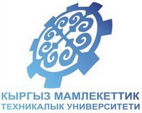
Kyrgyz State University
Technical University
named after I. Razzakov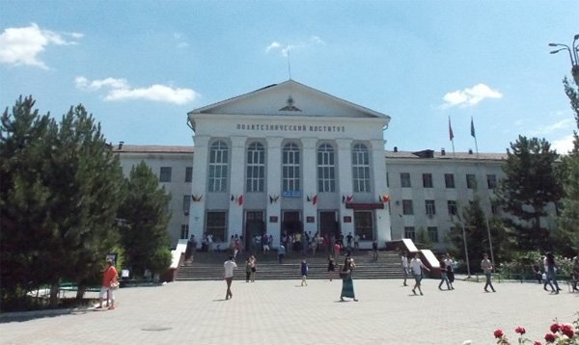

Department
"Economic security and Marketing"
Education is your capital!

Bishkek

