***ATTENTION APPLICANTS!***

***We inform you that in***

***Energy Institute of***

***KSTU named after. I.Razzakov***

***a new profile has opened***

***"Digital automation systems in the power industry»***

***towards "Electrical power engineering and electrical engineering"***

As is known today, many energy companies, both domestic and foreign, are moving along the path of implementing “smart energy” solutions and need specialists with knowledge in the field of information technology, digital transformations in the electric power industry and mastery of modern software products used in the design and analysis of energy facilities.

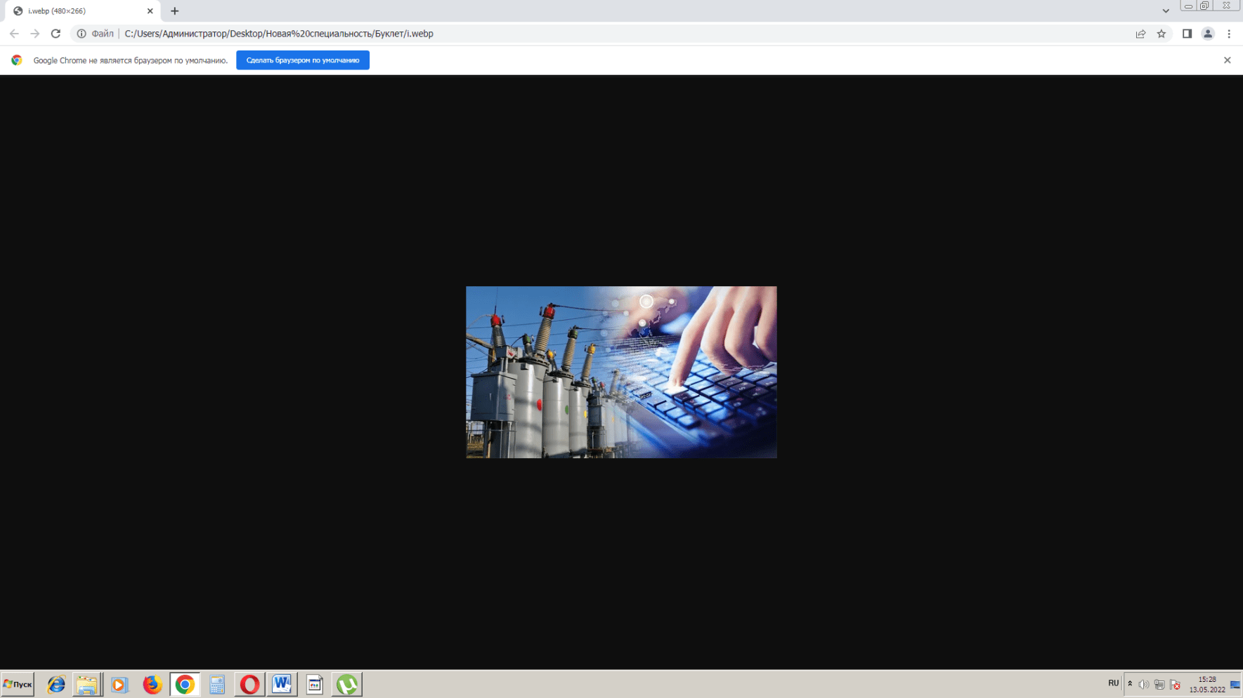

Advantages of the training profile "*Digital automation systems in the power industry*» consist in the fact that in addition to basic knowledge in special disciplines in the areas of "Electrical power engineering and electrical engineering "related to the production, distribution and consumption of electrical energy, students will also receive advanced knowledge in the following areas: Programming languages ​​and methods; Database; Digital signal processing;Cybersecurity in the electric power industry; SmartGrid (Smart networks); Scada systems in electrical power systems; Digital technology and micro-controllers; Computer-aided design systems in the electric power industry, Internet of Things, IoT technologies, and many other interesting items.

The knowledge that graduates of our profile will receive will allow them to work in leading generating, transmission power grids, installation and commissioning, operational dispatch, sales and design energy organizations in Kyrgyzstan, as well as countries near and far abroad. Today, up to 90% of graduates of the Faculty of Energy are employed in their specialty.

The Department of Technology and Energy has a good laboratory base and a computer lab. About 60% of the teaching staff are candidates of technical sciences, excellent students of education and honored energy workers of the country, with scientific works in the field of intelligent (digital) power engineering, published in English in the world's leading scientific journals with high ratings (Great Britain, Switzerland, Poland, Japan, etc.) and participating in international conferences abroad.

The Energy Institute, including the Department of Technical and Electrical Engineering, cooperates with leading universities in the CIS and far abroad, such as the Moscow Energy Institute, Tomsk Polytechnic University, Kazan State Energy University, Almaty University of Energy and Communications, Berlin Technical University of Applied Sciences, etc.

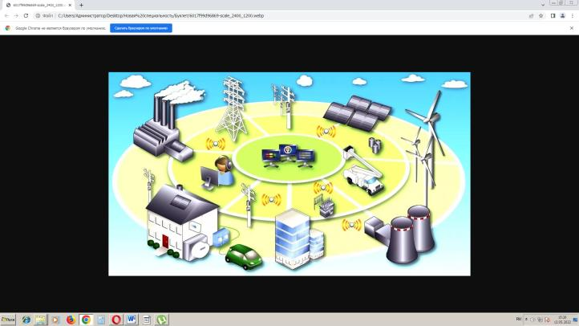

Long-standing and reliable partners of the institute are all major energy companies, OJSC National Electric Networks of the Kyrgyz Republic and its subsidiaries, OJSC Electric Stations, Bishkek CHP and the largest hydroelectric power plants in the country. And today these energy companies. There is an urgent need for energy IT specialists, and accordingly, graduates of our department will easily be able to find employment in the future!

**Tuition fee: 42900 soms.**

**Full-time form of education**

**Budget places: available**

**List of mandatory subject tests:** main test, physics or mathematics

**Required documents upon admission:**

- Certificate of secondary education;

- All-republic testing Certificate;

- Photos 4 pcs. (3x4);

- Copies of passport and registration certificate

(for those liable for military service).

**Come to us**

**we will be glad to see you within the walls**

**our university!**

**KYRGYZ STATE**

**TECHNICAL UNIVERSITY**

**them. I.RAZZAKOVA**

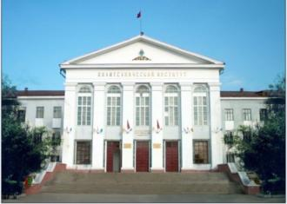

**ENERGY INSTITUTE**

|  |  |
| --- | --- |
| **profile**  "Digital automation systems in the electric power industry" |  |

**Address: 720044, Bishkek,**

**Ch. Aitmatov ave., 66, KSTU named after. I. Razzakov**

# **EI Directorate, room 1/370, tel.: +996 312 545 130**

**e-mail:** [**dekanef@bk.ru**](mailto:dekanef@bk.ru)

**Admissions Committee: +996 312 541 921,**

**+996 701 400 625**

[**www.kstu.kg**](http://www.kstu.kg)

**Bishkek – 2024**