"Higher School of Economics and Business"
Department of "Economic Security and Marketing"

Report

Curators of groups M(b)-1-22, EB (c)-1-22, EB (c)-1-21, M (b)-1-21, ECObuh.1-21
Rev. kaf "EBiM"
Elchibayeva A.Z., Kubatbekova L.T., Toybayeva N.R., Baktybekova A.B.
about the work done for the 2022-2023 academic year.

Bishkek 2022
Information autumn semester of the 2022-2023 academic year
General information about groups.

Educational work of the group for the 2022-2023 academic year in groups M(b)-1-22, EB (c)-1-22, EB (c)-1-21, M (b)-1-21, ECO buh.1-21.
The following tasks were assigned to the teachers of the Department of "Economic Security and Marketing":
1. to build constructive interaction with the head of the department, teachers working in a group of students;
2. to implement a personality-oriented approach that provides and supports the processes of self-knowledge and self-realization of the student's personality;
3. continue to form a responsible attitude to academic work, interest in the chosen specialty;
4. continue to foster feelings of patriotism, citizenship, a stable and positive attitude to culture, to their health;
5. contribute to the disclosure of individual abilities of each student;
6. develop creative and communicative skills; social activity;
7. develop a system of self-management in the group.
The purpose of educational work in the group is to create conditions for the development of a highly educated, humanistically oriented personality, focused on creativity and self-development, the formation of a healthy lifestyle and moral behavior in the process of educational activities of students of the group by means of personality-oriented learning.

Characteristics of the collective group and individual students

The composition of the groups is 55 people, at the time of writing the report.
The headmen of the groups are Amanturova Zhanna, Koshueva Samara, Marat K. Nagima, Baisheva Yu., Nogoibekova Zh. – responsible and active, assistant curator.

A student of the EB group from 1-19 A. Abdyzhaparova received a scholarship from the rector of the I.Razzakov KSTU M.K. Chynybayev based on the results of her academic performance and activism.
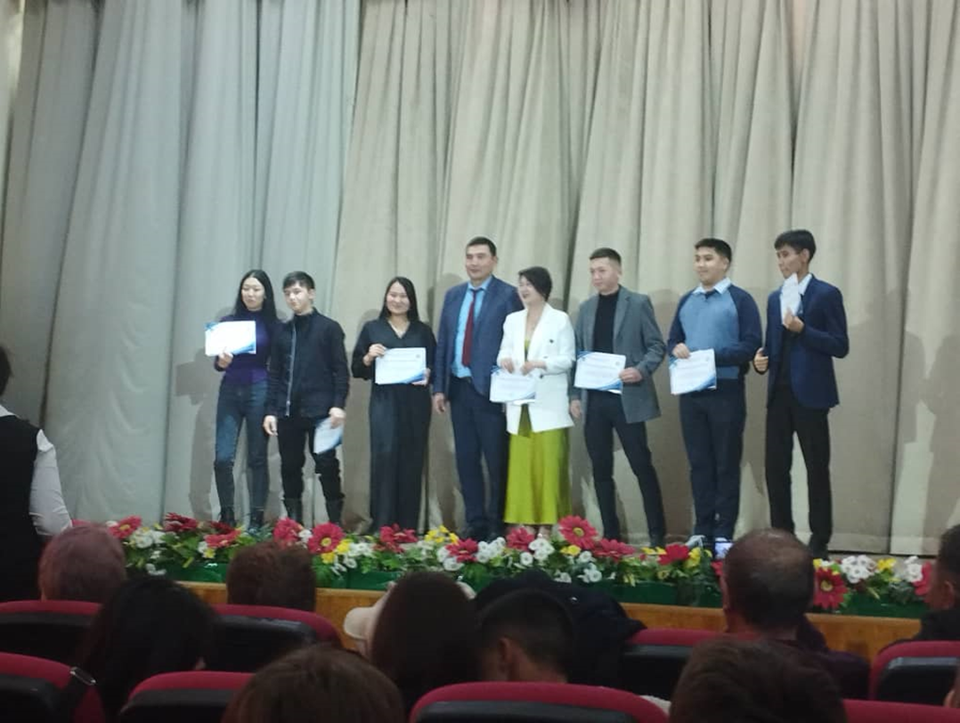
Baktybekova Akinai, an activist of the groups, responsibly and conscientiously performs all functions and duties, is an assistant to the headman, helps to monitor the progress and attendance of students of the group.
The group has a positive microclimate. All students communicate constructively with each other, peacefully resolve the conflict situations that have arisen. Most of the group of students are active, responsible, there are no isolated and rejected members of the group. The culture of behavior and the culture of appearance meet the requirements established in the college. All students of the group feel comfortable among their peers, there are no conflicts.
The majority of students in the group have a responsible attitude to academic work and an interest in their future specialty. The students showed their individual abilities: they showed themselves in the events.

The students of the groups showed high activity, responsibility and independence:
1. Baktybekova Akinai M(b)-1-22
2. Baisheva Yu. M(b)-1-21
3. Marat K. Nagima EB (c)1-21
4. Tumonbaeva Zharkynai ECO boom.1-21

According to the plan of educational work, the following activities were carried out with students:
1. Familiarization of group students with the curriculum and schedule of the educational process in the form of an additional group meeting-conversation.
2. Acquaintance of students with active creative associations, collection of applications from students.
3. Choosing a student asset. Organization of student self-government in the group, familiarization with the functions of students.
4. Survey of students on the problem of identifying interests, inclinations.
5. Observation of students in the online learning format, active participation during classes in each subject.
6. Prevention of smoking, immoral lifestyle, suicidal behavior, conflict situations in a group with peers and teachers - in the form of meetings and conversations organized by deputy deans for educational work and representatives of the "Committee for Youth Affairs" of the university.
7. Conversations with students: adaptation to new living conditions, organization of conditions for homework online; compliance with the rules of residence in the hostel;
8. Individual conversations with students on the issues that have arisen during the online training period.
9. Analysis of attendance and academic performance of students of the group, as well as thematic class hours conducted according to the curator's plan: "Online visits to world-class museums and theaters", "Student ethics during online education" and others.

The methods of education used:
- cooperation,
- individual and group conversations in zoom conferences,
- persuasion,
- attending classes,
- discussion of the results of training and practice,
- monitoring of student activity,

Work with students was carried out:
- curatorial hours;
- individual phone conversations, what's app, zoom.
Daily:
1. Interview with students who are late and find out the reasons for their absence.(via zoom)
2. Individual work with students. (via zoom)
Weekly:
1. Checking the group log.
2. Holding events in a group (according to the plan).
3. Work with parents (according to the situation).
4. Work with subject teachers (according to the situation).
Every month:
1. Checking the group log.
2. Meeting of the group's asset.
Payment report for the 2022-2023 academic year
FOR THE FIRST HALF OF THE YEAR.
There is no debt for the department.

Cultural and mass work of the following groups.
1.12.22. World AIDS Day is celebrated annually on December 1. People all over the world unite to show support to people living with HIV or affected by HIV infection in one way or another, and remember those who died from AIDS-related diseases. On December 1, 2022, the HSE hosted an event dedicated to the International AIDS Day. The events are aimed at informing students about the problem of HIV infection, the formation of a healthy lifestyle. The lecture was conducted by the doctor KUZ Toktogulova Anarkan Moldobekovna and the head of the health center Uchkempirova Zhyldyz Askaralyevna.
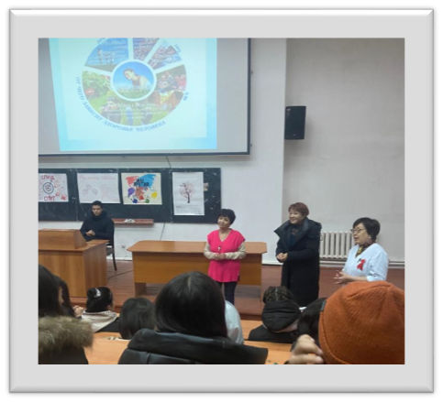
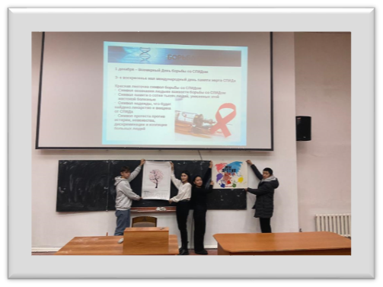
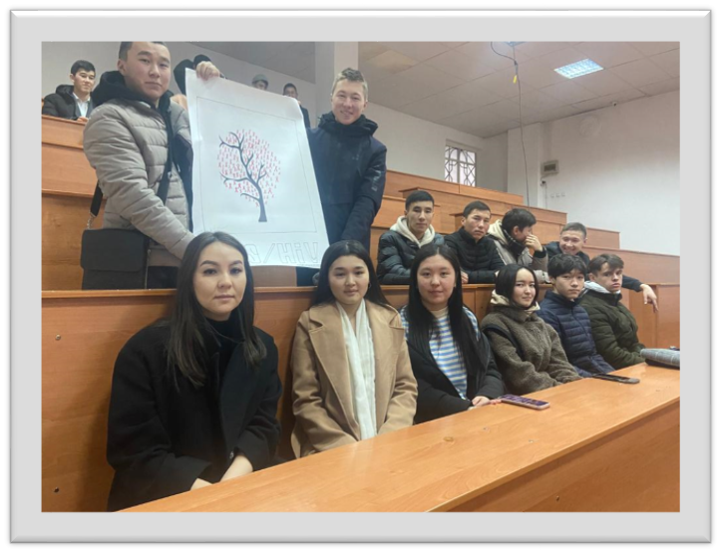
On 2.12.2022, there was an event "Dedication to students", a student of the group M b 1 22 Baktybekova Akinai actively participated.
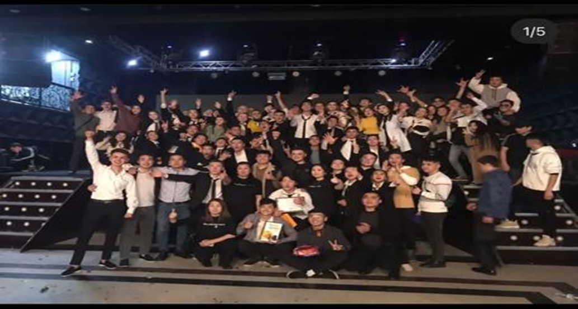
On 18.10.22, a "Job Fair" for senior courses was held, where groups EBs-1-19, EBks-2-19, Mb-1-19 participated.
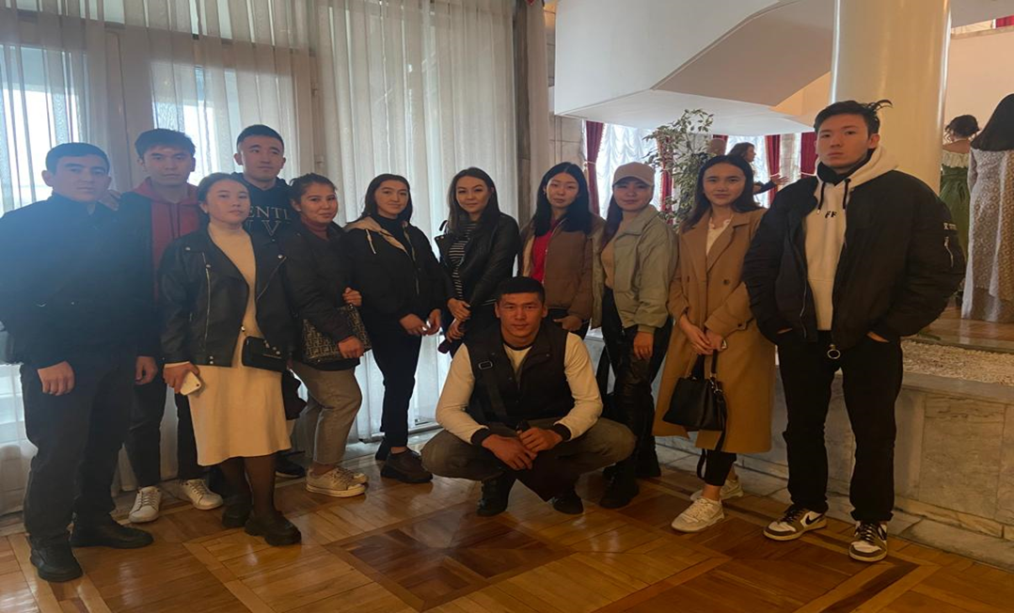

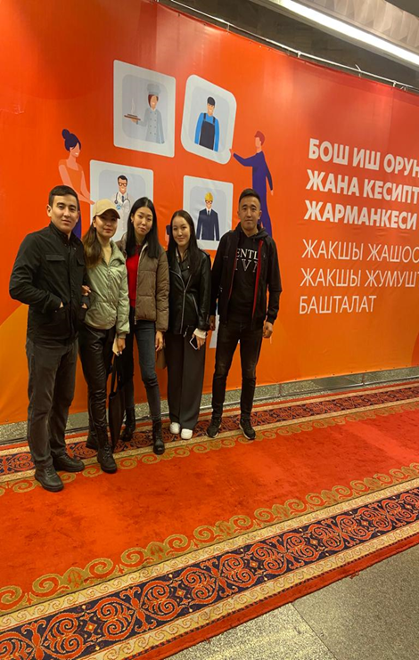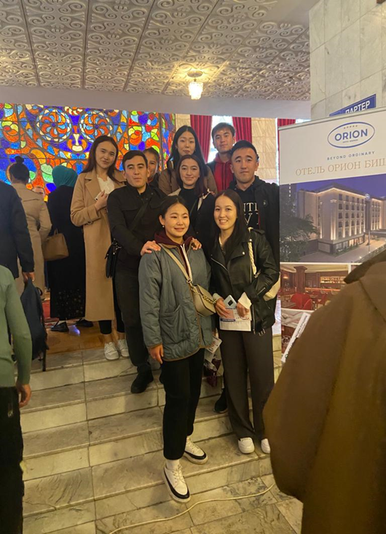

Curatorial hour
Korchubeka Aknazarova
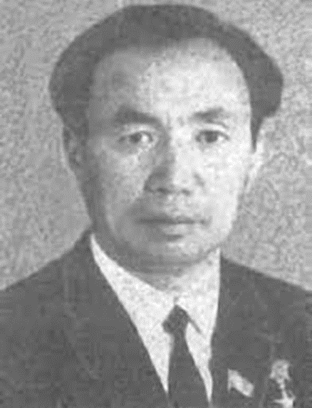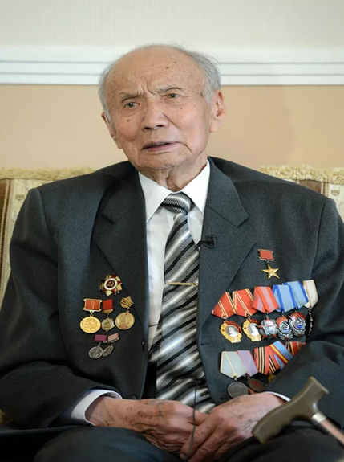
Korchubek Aknazarov was born on August 1, 1922 in the village of Kyzyl Oktyabr, Bakai-Ata district, Talas region. He began his career in 1941 as a teacher at a rural seven-year school.
In 1943, he was mobilized into the ranks of the Soviet Army, fought against the invaders on the first Belorussian front. He reached Warsaw, was wounded while crossing the Vistula River. He was awarded the Order of the Patriotic War of the first degree and medals. In 1946, he returned to his homeland, worked as the head of the educational part of a seven-year school in the Chatkal district.
Since 1947, Korchubek Aknazarov, working in party work, devoted his whole life to selfless service to his people, his country. In the beginning, he became the head of the party cabinet, then the head of the propaganda and agitation department of the Chatkal district Committee of the Communist Party. In 1952-1956, he was elected second, then first secretary of the Chatkal district Committee of the Communist Party, chairman of the Ala-Buka district executive Committee. In 1957-1961, he worked as the second secretary of the Oktyabrsky and Bazar-Korgon district committees of the Communist Party of Kyrgyzstan.
From 1961 to 1990, he successfully worked as the first secretary of the Ak—Talin, Jumgal and Kochkor district committees of the Communist Party. In 1965 he graduated from the higher party school of the Central Committee in the city of Alma-Ata. He was elected a delegate to the XXV, XXVI-congresses of the CPSU. For many years he was a member of the Central Committee of the Communist Party of Kyrgyzstan.
Under his leadership, the mountainous regions have achieved significant success in the development of animal husbandry and agriculture. There have been dramatic changes in the economy, social and cultural life of the regions.
For his long-term and conscientious work, Korchubek Aknazarov was awarded the high title of Hero of Socialist Labor in 1966. He was awarded two Orders of Lenin, the Order of the October Revolution, two Orders of the Red Banner of Labor, as well as the Order of the Badge of Honor. He was elected a deputy of the Supreme Soviet of the Kyrgyz SSR of several convocations, after Kyrgyzstan gained state independence, he was also a member of parliament.
The name of Korchubek Aknazarov, along with outstanding figures who made an invaluable contribution to strengthening the Kyrgyz statehood, socio-economic development of our country, will forever remain in the history of Kyrgyzstan. His glorious life path, high human qualities, decency and modesty, as well as selfless work for the benefit of the people will be a model for all of us.
The bright image of Korchubek Aknazarov, a brilliant leader and organizer who devoted his whole life to serving his people, will forever remain in the grateful memory of our people.

Topic: For the birthday of Iskhak Razzakov (biography and creativity).
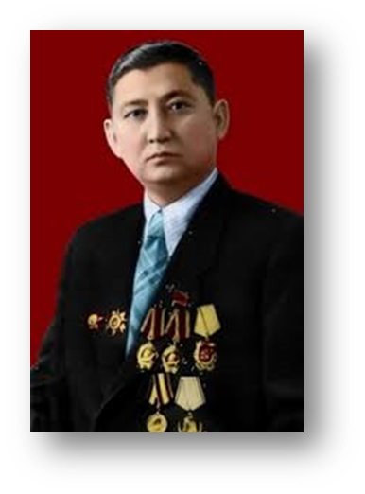
The long history of the Kyrgyz people is rich in bright personalities. Among them is the talented, outstanding personality of Iskhak Razzakov. Iskhak Razzakov is one of the statesmen who left an indelible mark on the political history of Kyrgyzstan in the Soviet era.
Razzakov Iskhak Razzakovich, an economic, Soviet and party worker, Kyrgyz, was born on October 25, 1910 in the village of Khorosan of the Box-Isfaninsky parish of the Khojent district of Turkestan Krai (now Laylyaksky district of Osh region) in the family of a miner. His childhood was very difficult. Razzakov's mother died when he was only three years old. At the age of five, on the way to Tashkent, he lost his father and was left alone among strangers. Until 1925, Iskhak was brought up and studied in an orphanage in Khojent. Iskhak Razzakov had a lively mind since childhood. In 1923 he is transferred to study in Tashkent, where he enters a boarding school of the 2nd stage named after him. Namuna. From 1925 to 1929, he studied at the Uzbek Institute of Education in Tashkent (Pedagogical College), where he then taught social studies from 1929 to 1931. At school, he studied brilliantly, noticeably standing out among his peers. Then in 1931 he was sent to study at the Moscow Gosplan Institute. Krzhizhanovsky. He also studies well there, actively participates in public life. Upon graduation, he defends a diploma on the topic of rational use of fuel resources and receives a specialty of an economist-planner. It should be noted that the State Commission during the defense noted the theoretical depth and practical significance of the final work.
Already at a young age, he was characterized by high education and spiritual and cultural level. From 1936 to 1941, he consistently held responsible positions as head of the fuel department of the State Planning Committee of the Uzbek SSR, chairman of the regional plan of the Fergana region, deputy chairman, and then chairman of the State Planning Committee of the Uzbek SSR. Fruitful ten-year work in Uzbekistan has shown outstanding organizational skills of I. Razzakov. The ability to manage people, to unite them in a team manifested itself during the Great Patriotic War. He found contacts and organically lived the interests of friends and comrades. Selfishness and self-interest were alien to him. These qualities at a high level of state and party activity have grown into a natural state of living in the interests of the people and putting their interests, the interests of the country above all.
Fate was kind to Ishaq Razzakov. In high circles of power, his outstanding abilities, brilliant knowledge, high responsibility for the assigned task, moral and strong-willed qualities were noticeable. At a very young age in 1945, by the decision of the Politburo of the Central Committee of the CPSU, the Soviet government, Iskhak Razzakov was sent to Kyrgyzstan as Chairman of the Council of Ministers. Then he was only 35 years old.
In the post-war economic life of Kyrgyzstan, there were serious problems in all sectors. Planning and economic education and long-term work in the State Planning authorities helped Razzakov to deeply and specifically understand economic issues. With the arrival of I. Razzakov, the Council of Ministers of the Republic noticeably improved its work. The appropriate order was put in place, labor discipline was raised. Leadership qualities helped him to lead the republic in 1950. During his leadership (from 1950 to 1961), new factories, factories, mines, power plants, irrigation systems, schools, residential buildings were built and put into operation. The hard work of people under the Leadership of I. Razzakov has brought its results. A large Frunze agricultural machinery plant was built, the high—altitude Frunze -Osh road. In 1946-1950, 20 large industrial facilities of the national economy were put into operation. Among them are Lebedinskaya, Alamedinskaya, Przhevalskaya HPP, Kirgizavtomash plants, Osh Electromechanical Plant, shoe factory in the capital, etc. The construction of the BCHK has been completed, the Orto-Tokoy reservoir has been irrigated and more than three thousand hectares of arid lands have been developed, thousands of people have moved to them. In 1956, a major victory was achieved in agriculture, the republic was awarded the first Order of Lenin.
People trusted him. Trusted and associates. With all his behavior, actions, actions, and service to the Fatherland, he deserved the recognition and love of the nation. Iskhak Razzakovich was a widely educated man. He attached great importance to science and higher education. The leader paid great attention to the training of highly qualified scientific personnel, university teaching staff, qualified engineering and working personnel for the branches of the national economy. Many young compatriots were sent to the Scientific and educational Centers of Moscow, Leningrad, and other cities of the USSR.
Iskhak Razzakovich initiated the establishment of the Academy of Sciences of the Kyrgyz SSR, the State University, the Frunze Polytechnic Institute, which bears his name today, and regional pedagogical institutes. Iskhak Razzakov is a great personality of Kyrgyzstan. And his name, as a statesman and politician, a popularly recognized leader of the nation, is rightfully vividly inscribed in the history of our state.
History of I. Razzakov KSTU
It originates in 1953, when due to the acute shortage of highly qualified specialists in the engineering industry of Kyrgyzstan, the technical faculty was established at the Kyrgyz State University. It was established on September 1, 1954, as the Frunze Polytechnic Institute. The first rector of the FPI was Professor Georgy Akimovich Sukhomlinov.
The training of future engineers was carried out by 12 faculties at 60 departments, where 13 thousand students studied in 26 specialties, 350 teachers (200 with academic degrees and titles). The FPI has become a forge for the training of highly qualified personnel for industry and construction of the Kyrgyz SSR and the entire Central Asian region.
In honor of the 50th anniversary of the formation of the USSR, the Jubilee Badge of Honor of the Central Committee of the CPSU, the Presidium of the Supreme Soviet of the USSR, the Council of Ministers of the USSR and the Central Committee of the CPSU was awarded to the staff of the FPI among the 26 best universities of the country in honor of the 50th anniversary of the formation of the USSR.
Since 1992 — I. Razzakov KSTU. Now the university is a modern university complex, the largest educational and scientific center for training and retraining of engineering, technical and engineering-economic personnel in 77 specialties.
KSTU owns innovative technologies and implements the latest educational programs. The university has more than 19 thousand students, as well as about 200 lyceum students and more than 190 graduate students and applicants.

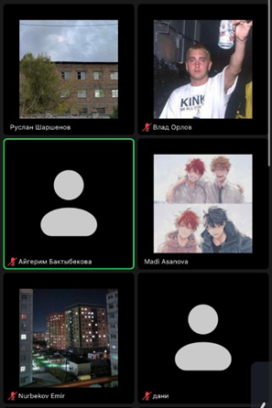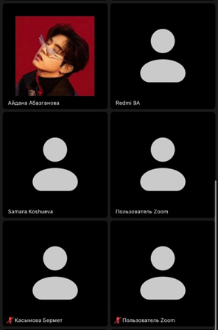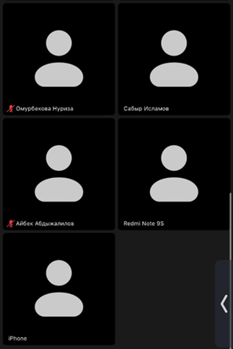

Conclusions.
For the period of the first half of the 2022-2023 academic year of study in the group M(b)-1-22, EB (c)-1-22, EB (c)-1-21, M (b)-1-21, ECO buh.1-21 there were no conflict cases involving the students of the group and there were no comments from the teachers about violations of the rules of behavior during classes.

Curators of groups
Candidate of Economics,
senior lecturer of the department "EBM" Elchibaeva A.Z.

senior lecturer of the department "EBM" Kubatbekova L.T.

Senior lecturer of the department "EBM" Toibaeva N.R.

lecturer of the department "EBM" Baktybekova A.B.

